Task 1:

Create a program that asks for a name and a number then repeats it that number of times.

**Working Procedure:**

This is a C# Console program. This program have User_input() and Out_Put(string name, int num) user define function. Out_Put() Method has 2 parameter one is string data type and another is integer data type. At first in this program call User_Input() method. Then show a message that is asking to take name input. When I input the name then it sow another message that is asking to take a number input. After taking number it call Out_put() method with this name and number parameter. Then it show the name input number times.

**Algorithm:**

In this program have two user define function then second function have two operator one is String and another is integer. In User_Input() I declare two variables and take input in this valuables. Then I call Out_put() function with this two variables. In Out_Put() function the string name is repeats it that number of time.

**Exception Handling:**

In this program I use try catch for error handling.

**Code:**

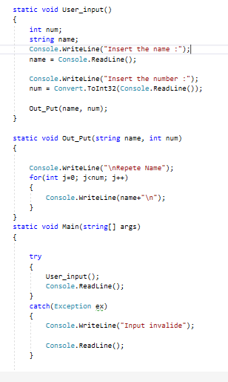

**Output:**

